**MG-SOFT MIB Browser Instructions**

The forwarding information of all SNMP nodes can be easily searched using SNMP MIB software, taking MG-Soft MIB Browser software as an example.

**1. Install**

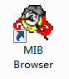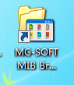Install Mib-Browser software by purchasing it from a third-party provider.

**2.** **Compile**

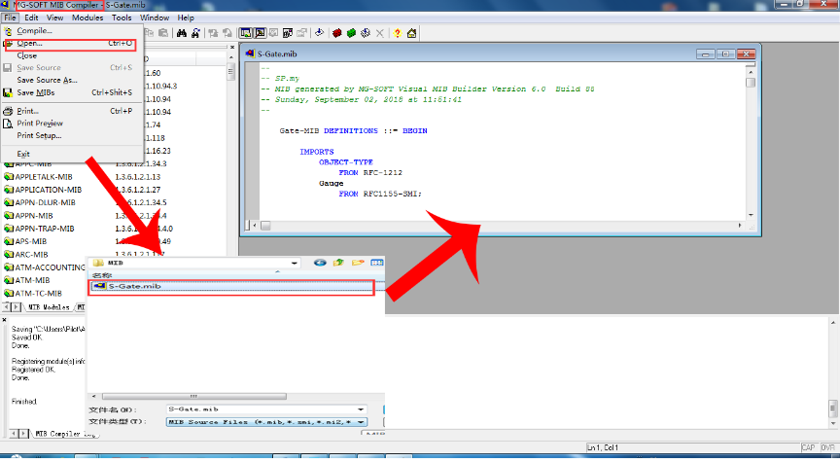

Open the MIB Comparer software and import the MIB file for the gateway

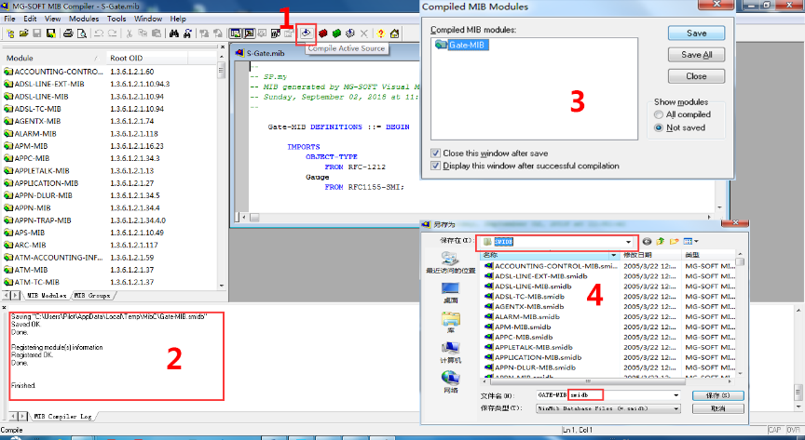

Compile and generate the files that SNMP requires.

When the compilation is completed, the Save window will pop up automatically, select the compiled file and click "Save" to Save to the SMI directory where the SNMP Browser software is located

**Note:** Must be placed in the SMI directory where the software installation directory is located, other locations are not available(The path is similar to....../ Mib Browser/Mib/SMIDB).

**3. Link**

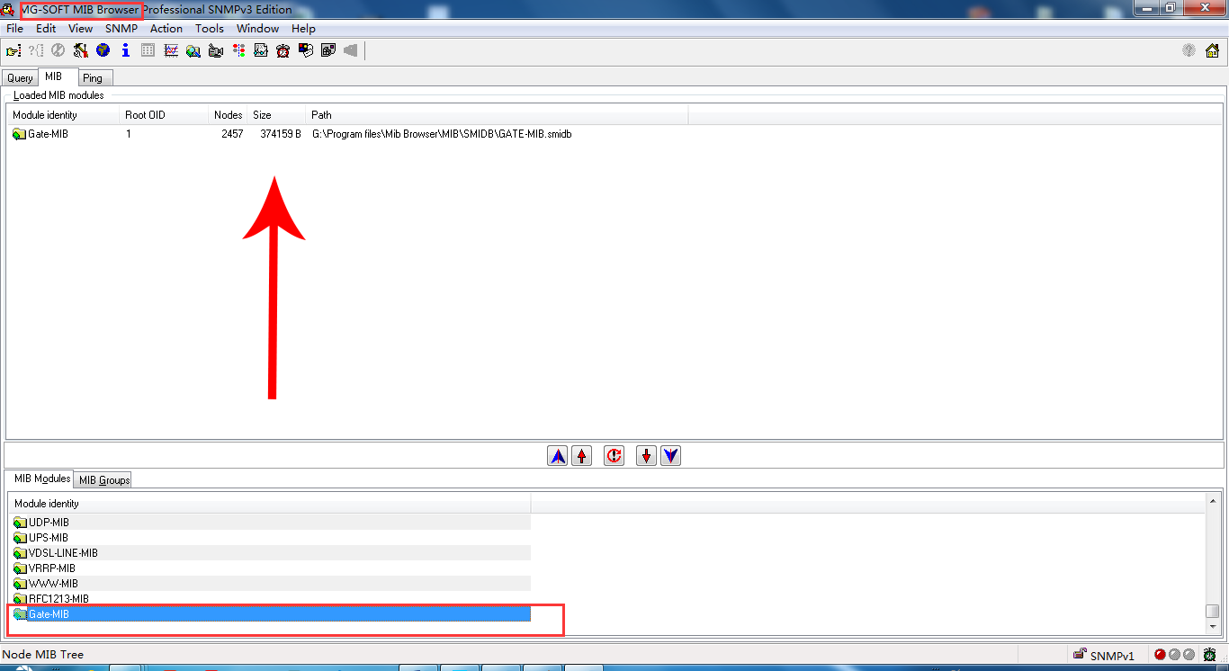

Open the MIB Browser software, find the compilation file you just saved in the MIB interface, and double-click to load it into Browser.

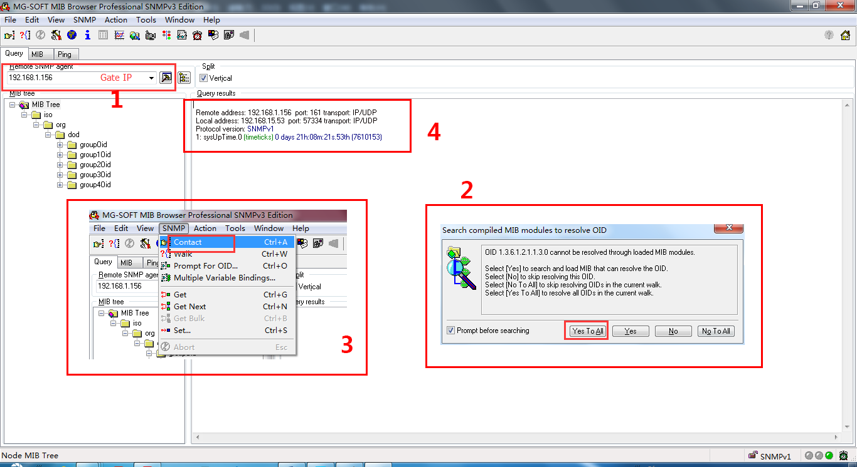

Switch to the Query interface, enter the IP address of the gateway, the node loading window will pop up, and select "Yes to all" to connect IP. When the connection is successful, the system node information can be obtained.

**4.** **Get node information**

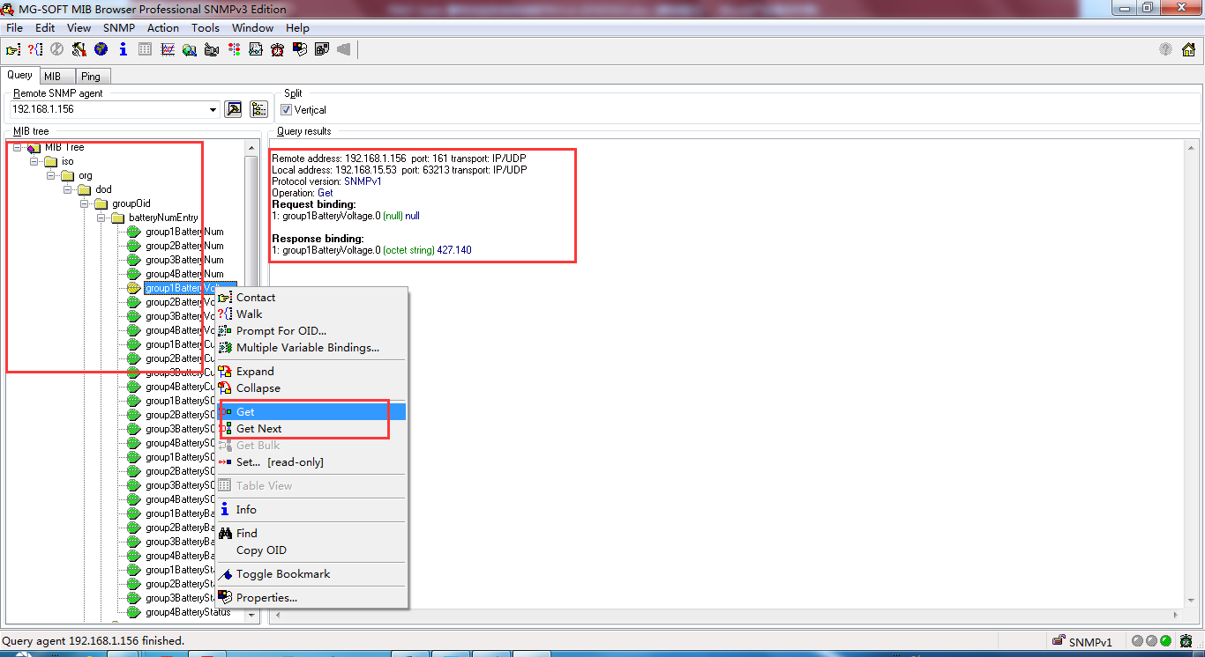

Click the node list, select the SNMP node to be obtained, and right click "Get" to obtain the corresponding node information.